A Parent's Guide to Google classroom
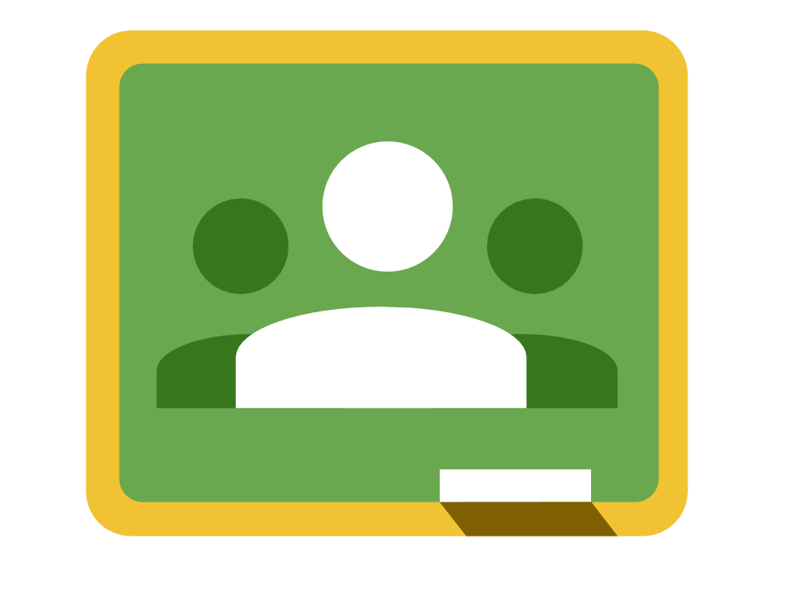
Google Classroom is a web-based learning tool that teachers use to post assignments, communicate with students, and provide feedback on student work.

This year we will be using the Google Classroom for pupils to submit home learning challenges. In school, we also use the digital classroom for students work. This guide will provide an overview of Google
classroom and introduce you to some tools that you can use to support your students learning.
Table of Contents
Accessing Google Classroom Classroom Home Page
The Stream page The Classwork page Types assignments
The Assignment page

Accessing Google Classroom
Your student can access Google Classroom using a phone (iPhone or Android), tablet, or computer (Mac, PC, or Chromebook).

Students will use their school provided email address to log in to Google Classroom. Details on the next page.

Parents do NOT have direct access to Classroom, but are welcome to log in with their student to review course content.
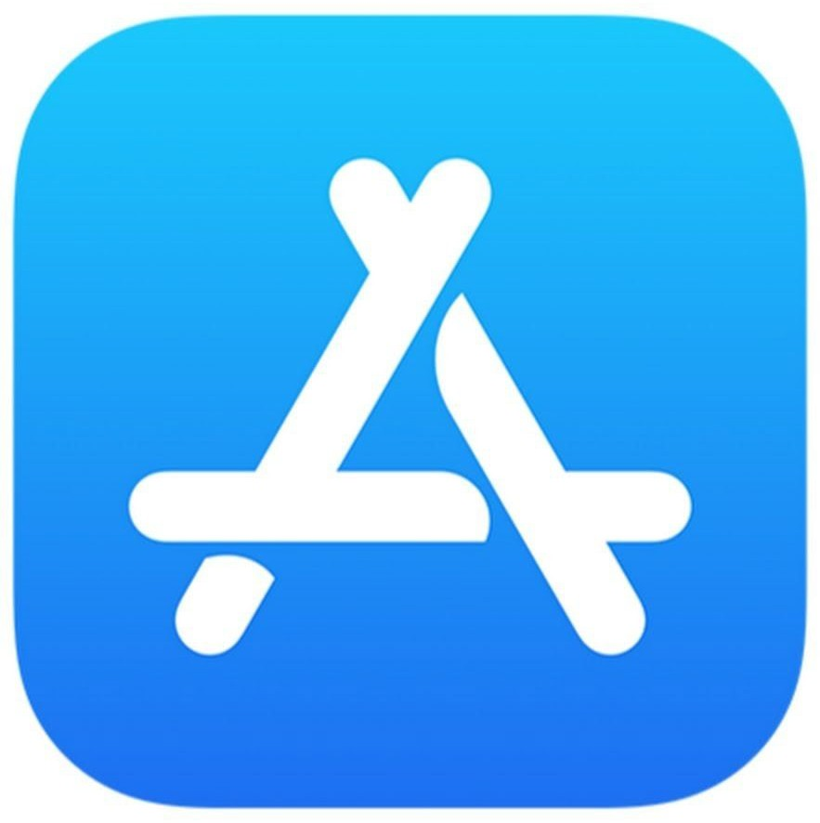 | 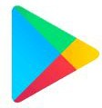 | 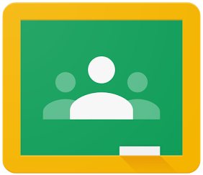
Visit the iOS App Store | Visit Google Play on | Visit
on your iPhone or iPad | your Android phone or | classroom.google.com
to download the Google | tablet to download the | on your Mac, PC, or
Classroom app. | Google Classroom App. | Chromebook to log in.

Classroom Home Page
Ask your student to sign in to Google Classroom using their school provided Google account. This is their normal username they use to log into school computers with @victoriaparkschool.co.uk at the end. (They do not have access to an email address)
Example for a Y6: 20MillyZ@victoriaparkschool.co.uk
20 being the year they started at VPJS, Milly is the first name and Z is the initial of their surname. They should have this username and password in their learning journals.

The Classroom home screen displays the pupils digital classroom.

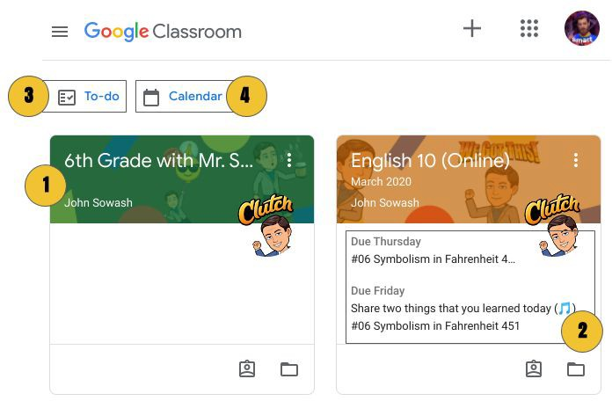

1⃣ Each class will be displayed as a card.
2⃣ Upcoming assignments will be display on the class card for each class
3⃣ The “to do” page lists upcoming assignments and late work.
4⃣ The class calendar displays upcoming assignments by due date

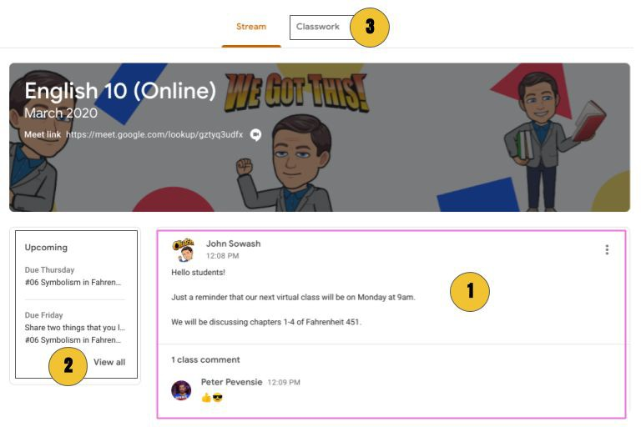
The Stream page
Click on a course card to open a class.

You are now on the “stream” page. This is where teachers will post announcements and reminders.

Students will not be able to post comments or replies on announcements.

1⃣ Teachers use the stream page to post announcements and reminders.
2⃣ The stream page lists upcoming assignments.
3⃣ The Classwork page is where assignments are posted.

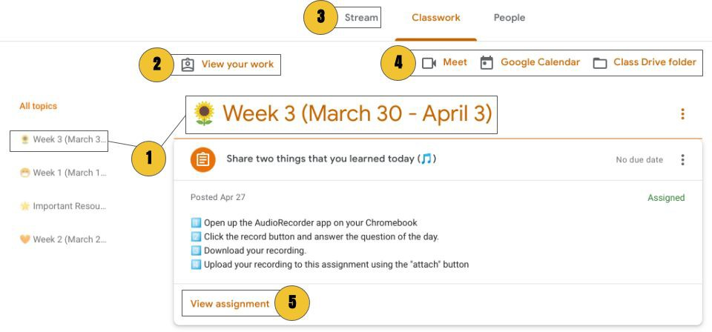
The Classwork page
Click on classwork at the top of the stream page.

This is where class assignments are posted.

Student will spend most of their time on this page, reviewing, and completing course work assigned by the teacher.

1⃣ The classwork page is organised into topics. Teacher will use topics to organise assignments by week, chapter, unit, or subject area.
2⃣ Students can view a summary of all of their upcoming assignments by clicking “view work.”
3⃣ You can navigate back to the stream by clicking the link at the top of the screen.
4⃣
5⃣ Students should click on an assignment to preview it. To view all of the assignment details, click “view assignment.”

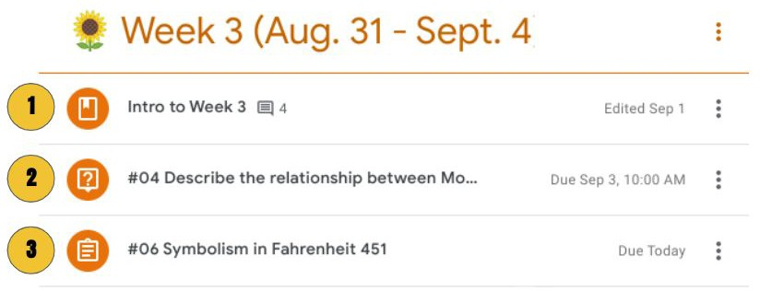
1⃣ Material - this is a reference or resource post. There isn’t anything to turn in or submit.
2⃣ Discussion Question - discussions can be free response or multiple choice.
3⃣ Assignment - Teachers use the assignment post for homework, quizzes, group projects.
Your student will see three types of assignments
Types assignments

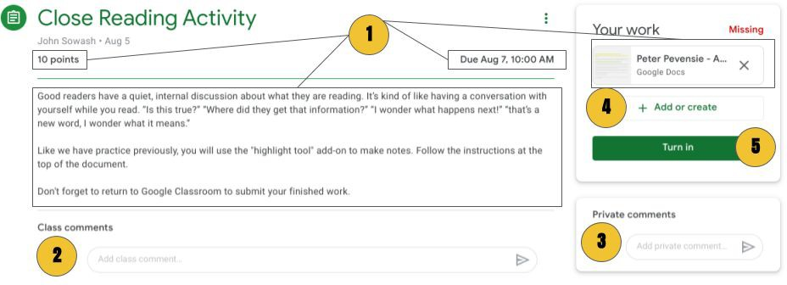
The Assignment page

Click on an assignment listed on the classwork page.

The assignment page is full of important information and details about each assignment. Students should carefully read the directions and guidelines posted on this page.

1⃣ The assignment page lists the due date, number of points, and any files that are needed to complete the assignment.
2⃣ If enabled, students can post a class comment to ask for help from their classmates.
3⃣ Got a question about an assignment, send a private comment to the teacher!
4⃣ If instructed, students can attach files to send to the teacher. You can attach files from Google Drive or upload files from your computer or camera roll.
5⃣ Don’t forget to submit your work

